Project Report On

Corporate Event Management System



# Project Report Course Code : CSC 387

**Course Title**: System Analysis & Design

# Submitted To :

Md.Alamin Talukder Assistant Professor,IUBAT Department of CSE

**Submitted By:**

**Section: F**

|  |  |
| --- | --- |
| Name | ID |
| Tonmoy Sarker | 22203004 |

**Abstract**

The Corporate Event Management System is a web-based platform designed to simplify and streamline the planning and management of corporate events. Developed using PHP, XAMPP, HTML, CSS, and JavaScript, the system offers features such as event scheduling, participant registration, venue selection, and resource allocation. Its goal is to enhance productivity, reduce manual efforts, and provide a seamless user experience through a dynamic front-end and a robust back- end framework. By addressing the challenges of traditional event management practices, this system ensures efficient, scalable, and secure operations tailored to the needs of corporate organizations.

# Acknowledgments

I would like to express my sincere gratitude to my mentor Md. Alamin Talukder for their invaluable guidance and support throughout this project. I also extend my thanks to my peers and colleagues for their constructive feedback and encouragement, which helped refine this work. Special acknowledgment goes to the creators and communities behind XAMPP**,** PHP, and related technologies for their open-source contributions, which made this project possible. Finally, I am deeply thankful to all who supported and believed in me during this journey.

**Table of Contents**

**Abstract** i

Acknowledgments ii

List of Figures iii

List of Tables vi

Chapter 1. Introduction 8

* 1. Objectives of BCSE Program 9
  2. Source of the Report 9
  3. Methodologies 10
     1. Primary Sources 10
     2. Secondary Sources 10
  4. Objectives 11

Chapter 2. Organizational Overview 13

* 1. Mission 14
  2. Vision 14
  3. Organization Services 14
  4. Address of Office 16

Chapter 3. Methods 17

* 1. Planning Phase 18
  2. Design Phase 19
  3. Development Phase 21
  4. Testing & Deployment Phase 22
  5. Maintenance & Updates 23

Chapter 4. Conclusion & Upcoming Features 29

Reference 30

# List of Figures

* + 1. Figure 2.1: ESL Event planner office 15
    2. Figure 3.1: Use Case Diagram (illustrating how event organizers 19

and users interact with the system

* + 1. Figure 3.2:DFD Diagram 21
    2. Figure 3.3: XAMPP database 22
    3. Figure 3.4: Wireframe Design for Event Dashboard. 22
    4. Figure 3.5: Frontend UI Design Screenshot. 24
    5. Figure 3.6: PHP Code Snippet for Event Creation 24
    6. Figure 3.7: Screenshot of the deployed Event Management System 25

on the live server.

# List of Tables

Iterative Development: Continue to improve and enhance the system 24

based on user feedback

# Chapter 1 Introduction

# Objectives of BCSE Program

The Bachelor of Computer Science and Engineering (BCSE) program is a comprehensive academic curriculum aimed at developing skilled professionals in the field of computer science and technology. The primary objective of the BCSE program is to equip students with a deep understanding of computer science principles, including algorithm design, software engineering, database management, and system architecture. The program fosters a problem-solving mindset, enabling students to analyze complex problems and devise effective solutions.

Another critical aspect of the program is its emphasis on hands-on learning and real-world applications. Students are encouraged to work on projects, internships, and research assignments to bridge the gap between theoretical knowledge and practical implementation. The BCSE program also focuses on emerging technologies such as artificial intelligence, cybersecurity, and data science, preparing students to adapt to the rapidly evolving technological landscape. Furthermore, the program promotes teamwork, communication, and ethical responsibility, ensuring that graduates are not only technically proficient but also effective collaborators and responsible professionals.

By aligning with industry needs and global technological trends, the BCSE program aims to produce graduates who can contribute significantly to the IT sector and other technology-driven industries. It also serves as a foundation for students aspiring to pursue higher studies or specialize in niche areas of computer science.

# Source of the Report

This report is based on the practical implementation and documentation of the **Corporate Event Management System** project, a key requirement of the BCSE program. The project serves as a culmination of the knowledge and skills acquired during the academic journey, showcasing the ability to apply concepts to real- world scenarios.

The primary source of this report is the development lifecycle of the project, including the stages of problem identification, requirement analysis, system design,

implementation, and testing. Regular consultations with instructors and feedback from peers also played a significant role in shaping the project and ensuring its alignment with academic and industry standards.

Secondary sources included an extensive review of existing literature, research articles, and technical resources related to event management systems and web development technologies. Online tutorials, documentation, and forums provided additional insights into best practices and problem-solving techniques. These combined sources contributed to a well-rounded approach to project development and its subsequent documentation in this report.

# Methodologies

The development of the **Corporate Event Management System** was guided by a structured and systematic methodology to ensure the project's success. Each phase of the project was meticulously planned and executed to meet the defined objectives and deliver a functional, reliable, and efficient system.

# Primary Sources

The primary sources for the project included:

* + - * **Hands-on Development:** Active involvement in designing, coding, and testing the system components. This process helped in understanding the intricacies of event management systems and how to address common challenges.
      * **Mentor Guidance:** Regular interactions with instructors and mentors who provided valuable advice and critical feedback at various stages of the project.
      * **User-Centric Testing:** Observing and evaluating the system's performance based on user interactions to ensure a seamless and intuitive user experience.

# Secondary Sources

Secondary sources were critical in supplementing the primary efforts and included:

* + - * **Online Learning Platforms:** Tutorials and guides on PHP, XAMPP, HTML, CSS, and JavaScript to enhance technical proficiency.
      * **Technical Forums and Communities:** Platforms such as Stack Overflow and GitHub, which provided solutions to coding challenges and insights into industry practices.
      * **Research and Literature Review:** Academic papers, articles, and textbooks on event management systems and software development methodologies to ensure a sound theoretical foundation.
      * **Tool Documentation:** Official documentation of XAMPP and related technologies for understanding system configuration and best practices.

# Objectives

The **Corporate Event Management System** was undertaken with the following objectives in mind:

1. **Develop a Comprehensive System:** To design and implement a web-based platform that addresses the multifaceted requirements of corporate event management.
2. **Streamline Event Processes:** To automate and optimize key tasks such as event scheduling, participant registration, resource allocation, and communication, reducing manual effort and errors.
3. **Apply Theoretical Knowledge:** To integrate theoretical concepts learned during the BCSE program into a practical, real-world application.
4. **Enhance Technical Proficiency:** To demonstrate proficiency in web development technologies, including PHP, XAMPP, HTML, CSS, and JavaScript.
5. **Ensure Scalability and Security:** To build a system that is not only efficient and user-friendly but also scalable to accommodate future needs and secure to protect sensitive data.
6. **Support Organizational Efficiency:** To deliver a reliable solution that helps corporate organizations manage events more effectively, enhancing productivity and professional outcomes.
7. **Foster Learning and Growth:** To use the project as an opportunity to learn new skills, overcome challenges, and grow as a competent professional in the field of computer science and engineering.

This chapter serves as the foundation of the report, detailing the objectives of the BCSE program, the sources of information, the methodologies adopted, and the specific goals of the project. The subsequent chapters will delve deeper into the project's design, development, and outcomes, providing a comprehensive view of the work undertaken and its impact.

# Chapter 2 Organizational Overview

# Mission

The mission of the Corporate Event Management System is to revolutionize the way corporate events are planned, organized, and executed. The system is dedicated to providing a seamless, efficient, and user-friendly platform for event management, ensuring that organizations can focus on their core activities while leaving the complexities of event coordination to a robust digital solution. The project aims to reduce manual workloads, improve communication, and enhance overall event quality by leveraging modern web technologies. By addressing the specific needs of corporate clients, the system seeks to empower organizations to achieve their goals with precision and professionalism.

# Vision

The vision of the Corporate Event Management System is to become a leading solution in the event management industry by offering innovative, reliable, and scalable tools for corporate organizations. The system aspires to set a benchmark for efficiency and user experience, providing a platform that adapts to the evolving needs of businesses and technological advancements. By fostering digital transformation in event management, the system envisions enabling organizations to execute flawless events, build stronger relationships with stakeholders, and achieve sustained growth. Ultimately, the project seeks to contribute to a future where technology seamlessly integrates into every aspect of organizational operations, enhancing productivity and success.

# Organization Services

The **Corporate Event Management System** offers a wide range of services designed to streamline various aspects of event planning and management. These services include:

* + 1. **Event Scheduling:** The platform allows users to plan events with precision, selecting dates and times that align with organizational objectives and participant availability.
    2. **Participant Registration:** The system supports online registration, making it easy for attendees to sign up for events, reducing administrative overhead.
    3. **Venue Management:** Users can select and manage venues through the system, ensuring proper allocation of space and resources for events.
    4. **Resource Allocation:** The platform facilitates the efficient allocation of resources such as equipment, personnel, and catering services, ensuring smooth event execution.
    5. **Real-Time Notifications:** Automated notifications and reminders keep all stakeholders informed about event updates, reducing miscommunication and last-minute issues.
    6. **Data Management and Reporting:** The system provides tools for tracking event performance, managing attendee information, and generating detailed reports for evaluation and planning.
    7. **Customizable Features:** The platform offers customization options to cater to the unique requirements of different organizations, ensuring a tailored user experience.
    8. **Secure and Scalable Platform:** Built with robust security measures, the system ensures data protection while being scalable to accommodate future growth and increasing demands.

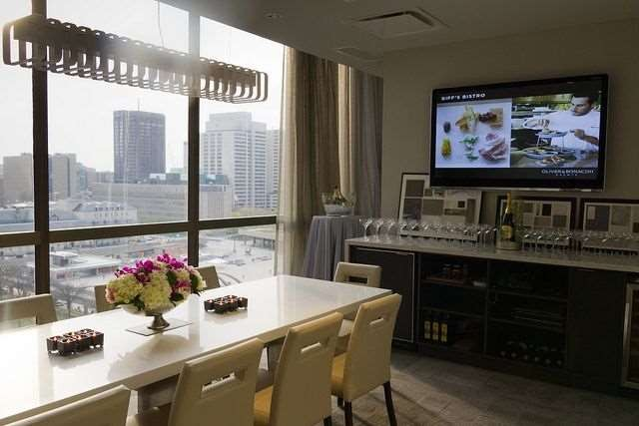

# Figure 2.1: ESL Event planner office

# Address of Office

The development and operations of the Corporate Event Management System are based at the following location:

# 16 Kemal Ataturk Ave, Banani, Dhaka 1213 Bangladesh

This address serves as the primary hub for the design, development, and management of the system. It provides the infrastructure and resources necessary for the successful execution of the project, including workstations, internet connectivity, and collaborative spaces for developers and stakeholders. The office's strategic location ensures accessibility for both local and international clients, fostering effective communication and coordination.

Through this organizational overview, the mission, vision, services, and operational details of the Corporate Event Management System are highlighted, offering a clear understanding of its purpose, capabilities, and foundational setup. Subsequent chapters will delve deeper into the technical and functional aspects of the system, showcasing its design, implementation, and impact.

# Chapter 3 Methods

* 1. **Planning Phase Process:**
     1. **Requirement Gathering**:
        + Identify the key functionalities and requirements for the event management system.
        + Meet with stakeholders to understand their needs.

# Feasibility Study:

* + - * Conduct a feasibility analysis of the system: technical, operational, and financial feasibility.

# Tools/Techniques:

* **Interview**: Talk to stakeholders.
* **Survey/Questionnaires**: Gather user requirements.
* **SWOT Analysis**: Evaluate the system's strengths, weaknesses, opportunities, and threats.

# Methodology:

* **Waterfall Methodology**: In this phase, we clearly define the project scope and requirements.
* **Use Case Diagrams**: Represent system functionalities.

# Image/Figure:

* **Figure 3.1**: Use Case Diagram (illustrating how event organizers and users interact with the system).

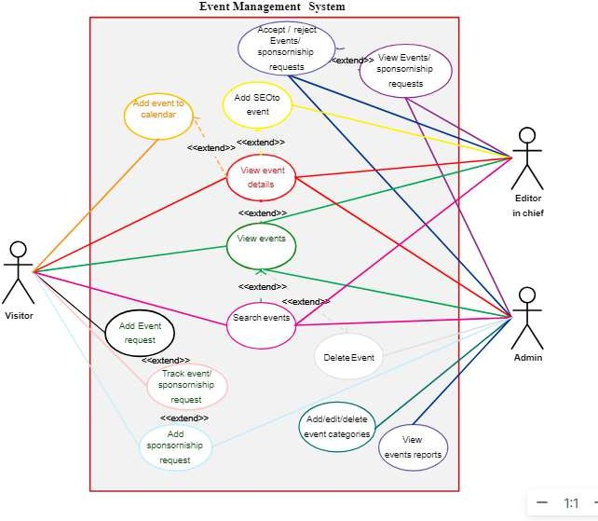

# Data Flow Diagram:

A **Data Flow Diagram (DFD)** helps visualize the flow of data within a system. For the **ESL Event Planner**, here's a conceptual outline of the data flow for both **Level 0 (Context Diagram)** and **Level 1 (Decomposed)**:

# Level 0 (Context Diagram):

* External Entities:
  1. **User**: Provides event details and requirements, receives status updates.
  2. **Administrator**: Manages users, payments, and event scheduling.
  3. **Service Providers**: Sends service availability and receives booking requests.
* System: The ESL Event Planner is the central system.

# Level 0 Flow:

1. **User** ➔ Provides event details ➔ **System**.
2. **System** ➔ Sends event plans ➔ **User**.
3. **Administrator** ➔ Updates system data (e.g., user profiles, payments) ➔

# System.

1. **Service Providers** ➔ Updates availability ➔ **System**
2. **System** ➔ Sends booking confirmations ➔ **Service Providers**.

# Level 1 (Detailed DFD):

1. **User Interaction**:
   * Input: Event requirements (e.g., date, type, budget).
   * Output: Event plan, status updates.

# Admin Functions:

* + Input: User and service provider data.
  + Processes: Validate payments, manage schedules.
  + Output: System updates, payment receipts.

# Service Provider Management:

* + Input: Service details (availability, costs).
  + Processes: Validate services, confirm bookings.
  + Output: Booking details, schedule updates.

# Database Management:

* + Stores: User profiles, events, payments, service provider details.
  + Processes: Retrieve and update .

**Fig 3.2 DFD diagram**

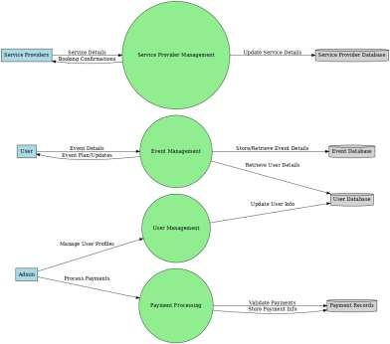

* 1. **Design Phase Process:**
     1. **System Architecture Design**:
        + Define the overall structure of the application ( front-end, back-end, database).
        + Identify the technologies and frameworks we will use.

# Database Design:

* + - * Create an Entity-Relationship (ER) Diagram to define entities and their relationships.

# User Interface (UI) Design:

* + - * Create wireframes for the user interface to show how the application will look.

# Tools/Techniques:

* **Wireframing Tools**: Use Figma or Adobe XD for UI wireframes.

# Tech Stack:

* + Frontend: HTML, CSS, JavaScript
  + Backend: PHP with XAMPP
  + Database: XAMPP)

# Methodology:

* **Object-Oriented Design (OOD)**: Design the system in classes and objects, making it easier to maintain and scale.

# Image/Figure:

* **Figure 3.3**: XAMPP database

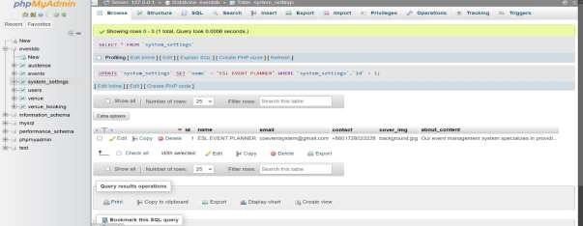

**Figure 3.4**: Wireframe Design for Event Dashboard.

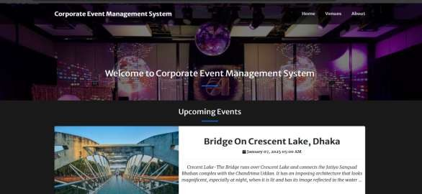

**3.5 Development Phase:**

**Process:**

1. **Frontend Development**:
   * Code the user interface using **HTML**, **CSS**, and **JavaScript**.
   * Make sure the UI is responsive and user-friendly.

# Backend Development:

* + Write PHP scripts to handle logic, database interactions, and dynamic content generation.
  + Implement CRUD (Create, Read, Update, Delete) operations for managing events.

# Database Integration:

* + Integrate MySQL database with PHP using **MySQLi** or **PDO** for secure data interaction.

# Testing & Debugging:

* + Continuously test each part of the system to ensure that it is functioning as expected.
  + Fix any bugs and ensure compatibility with different browsers.

# Tools/Techniques:

* **Frontend Tools**: Use **Visual Studio Code (VS Code)** for HTML, CSS, JavaScript development.
* **Backend Tools**: **XAMPP** (for running PHP and MySQL).
* **Database Tool**: **phpMyAdmin** (for managing MySQL databases).

# Methodology:

* **Agile Methodology**: In this phase, develop iteratively with regular testing after each functionality is added.
* **Version Control**: Use **Git** for code version control and **GitHub** for repository management.

# Image/Figure:

**Figure 3.6**: Frontend UI Design Screenshot.

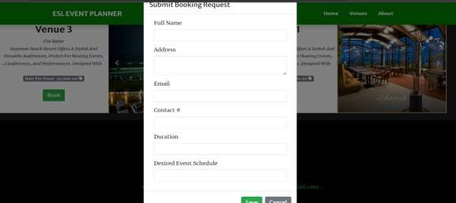

**Figure 3.7**: PHP Code Snippet for Event Creation.

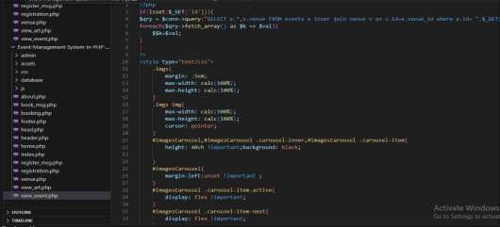

# Testing & Deployment Phase Process:

* + 1. **Unit Testing**:
       - Test each module (front-end, back-end, database) individually.

# System Testing:

* + - * Test the system as a whole to ensure all components work together.

# Deployment:

* + - * Deploy the application on a web server for live use.

# User Acceptance Testing (UAT):

* + - * Perform UAT by involving stakeholders to ensure that the system meets the requirements.

# Tools/Techniques:

* **Testing Tools**: Use **Selenium** for automated testing of the user interface.
* **Deployment Tools**: Use **FTP** to upload files to the web server or **AWS** for cloud deployment.

# Methodology:

* **V-Model**: Testing starts simultaneously with development to catch defects early in the process.

# Image/Figure:

* **Figure 3.6**: Screenshot of the deployed Event Management System on the live server.

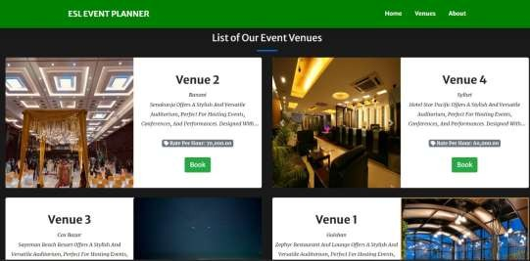

# Maintenance & Updates Process:

* + 1. **Bug Fixing**:
       - Identify and resolve any issues or bugs reported by users.

# Feature Enhancements:

* + - * Add new features as per user feedback, such as email notifications or calendar integration.

# System Updates:

* + - * Regularly update the system to patch security vulnerabilities and improve performance.

# Tools/Techniques:

* **Bug Tracking**: Use **Jira** or **Trello** to track bugs and issues.
* **Update Tools**: Regularly update **XAMPP**, PHP, and MySQL for optimal performance.

# Methodology:

* **Iterative Development**: Continue to improve and enhance the system based on user feedback

|  |  |  |  |  |
| --- | --- | --- | --- | --- |
| **Phase** | **Start Date** | **End Date** | **Tools Used** | **Deliverables** |
| Planning | 5th Dec,2024 | 7th Dec,2024 | Interviews, Surveys,  SWOT | Requirements Document |
| Design | 8th Dec,2024 | 16th Dec,2024 | XAMPP | System Design,  ER Diagram |
| Development | 17th Dec, 2024 | 26th Dec,2024 | Visual Studio Code, XAMPP,  phpMyAdmin | Functional Event Management System |
| Testing & Deployment | 27th Dec,2024 | 31th Dec,2024 | Selenium, AWS,FTP | Deployed Applications,Test  Results |
| Maintenance & Updates | 1st Jan,2025 | 4th Jan,2025 | Jira, Trello | Bug Fixes, Feature Enhancements |

# Chapter 4 Conclusion & Upcoming Features

**Conclusion**

The Corporate Event Management System project successfully delivered a scalable, user-friendly platform that addresses the needs of event organizers and participants. Despite the challenges encountered, the systematic approach adopted throughout the project lifecycle ensured its successful completion. This project not only demonstrates technical expertise but also lays the foundation for future development and enhancements, paving the way for innovative solutions in the field of event management.

# Upcoming Features:

The upcoming features of the "ESL Event Planner" include budget tracking, AI- powered suggestions, mobile app integration, real-time alerts, custom dashboards, advanced reporting, vendor ratings, and seamless integration with third-party tools. Additionally, the system will support guest management, virtual events, team collaboration, and enhanced security measures to provide a comprehensive and efficient event planning experience.

# References:

[**https://dhakaeventplanner.com/**](https://dhakaeventplanner.com/)[**https://www.anantabd.net/**](https://www.anantabd.net/)

[**https://www.cvent.com/en/blog/events/guide-corporate-event-planning**](https://www.cvent.com/en/blog/events/guide-corporate-event-planning)[**https://eventscase.com/blog/tips-to-become-a-corporate-event-planner**](https://eventscase.com/blog/tips-to-become-a-corporate-event-planner)[**https://eventify.io/blog/corporate-event-planning**](https://eventify.io/blog/corporate-event-planning)